

Mohd. Razia Alangir Banu
D. VENKAT SAI
2520090034
CSIT
CO-6

Case Study Topic: Meesho – Order Optimization & Resource Allocation System

Work Done Summary:
Meesho manages product delivery, warehouse storage, and order scheduling operations that require optimal resource utilization. Greedy algorithms are used for activity scheduling and route selection, while Dynamic Programming techniques such as Memoization and Tabulation are applied to solve optimization problems efficiently. The 0/1 Knapsack Problem is used to maximize product loading capacity in delivery vehicles. Longest Common Subsequence (LCS) helps analyze customer purchasing patterns. Matrix Chain Multiplication is used to optimize warehouse data processing operations. These techniques improve operational efficiency, reduce costs, and support decision-making in large-scale e-commerce systems.
Implementation Details:
- Greedy Activity Selection is used to schedule maximum delivery tasks without conflicts.
- Shortest path optimization is performed using greedy route selection techniques.
- 0/1 Knapsack Problem is implemented to maximize vehicle loading efficiency.
- Longest Common Subsequence (LCS) is used to identify similar customer purchase patterns.
- Matrix Chain Multiplication is applied to optimize data processing operations.
- Memoization and Tabulation techniques are used to reduce redundant computations and improve overall system performance.
Output:

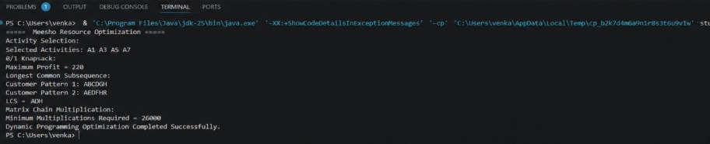

The Meesho resource optimization system successfully applies Greedy and Dynamic Programming techniques to solve scheduling, allocation, and optimization problems. These approaches improve operational efficiency, maximize resource utilization, and support data-driven decision-making in e-commerce environments.

Github Link: https://github.com/Venkat-267-byte/DSA-II

